Exercises
Session 2 (sections 4.2 and 4.3)

Weighted sum with resistor network

Norton and Thevenin equivalents

Exercise statement
Find the Norton and Thevenin equivalents of the circuit in Figure 7.
- : Circuit

12-lead ECG
Figure 9 shows a patient with ECG electrodes according to the Mason-Likar 12-lead system. Figure 10 gives the definition of the 12 leads of this system.
- : Mason-Likar 12-lead ECG system
- : Leads of the Mason-Likar 12-lead system

Exercise statement
Design a resistance network providing the 12 leads of the Mason-Likar system (as voltage signals).

Least mean squares

Bioimpedance analysis (BIA)
Bioimpedance analysis is a technique that measures the impedance (e.g., between the right hand and foot as shown in Figure 12) and, thanks to an equation, determines some features of the body, such as for instance the FFM (fat-free mass), i.e., the mass of the body without its fat. The equation is empirically determined from data measured on many people. Such data are, for instance those shown in Table 1. For every age range, two values are tabulated: $μ±σ$, where $μ$ is the mean and $σ$ the standard deviation.
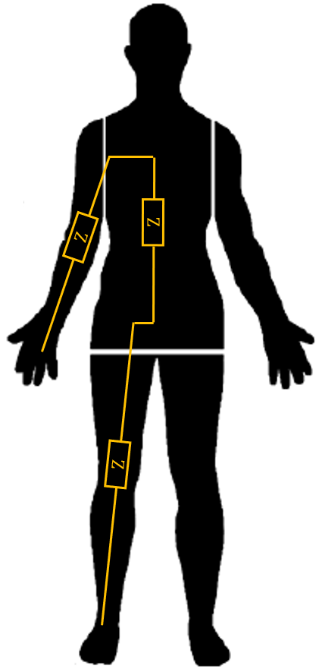
- : Bioimpedance analysis

- : Empirical data measured on $n$ people of 7 age ranges
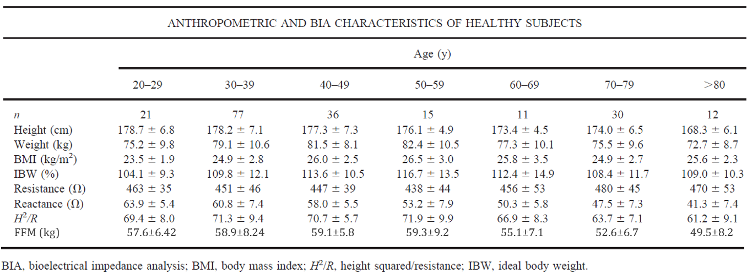

Exercise statement
From the information given in Table 1, compute the coefficients $x\left(1\right)$, $x\left(2\right)$, $x\left(3\right),$ $x\left(4\right)$—for instance by writing a Matlab/Scilab/Octave/Python script—providing the best estimation of the FFM according to the equation:
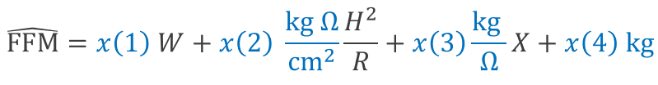
Additionally, determine the norm of the estimation error $e=FFM-\hat{FFM}$.
The figures of Table 1 are reproduced below to be easily copied/pasted.
21. 77. 36. 15. 11. 30. 12.
178.7 6.8 178.2 7.1 177.3 7.3 176.1 4.9 173.4 4.5 174. 6.5 168.3 6.1
75.2 9.8 79.1 10.6 81.5 8.1 82.4 10.5 77.3 10.1 75.5 9.6 72.7 8.7
23.5 1.9 24.9 2.8 26. 2.5 26.5 3. 25.8 3.5 24.9 2.7 25.6 2.3
104.1 9.3 109.8 12.1 113.6 10.5 116.7 13.5 112.4 14.9 108.4 11.7 109. 10.3
463. 35. 451. 46. 447. 39. 438. 44. 456. 53. 480. 45. 470. 53.
63.9 5.4 60.8 7.4 58. 5.5 53.2 7.9 50.3 5.8 47.5 7.3 41.3 7.4
69.4 8. 71.3 9.4 70.7 5.7 71.9 9.9 66.9 8.3 63.7 7.1 61.2 9.1
57.6 6.42 58.9 8.24 59.1 5.8 59.3 9.2 55.1 7.1 52.6 6.7 49.5 8.2

